This university works for holistic development of youth from unborn child to 18 years. Every child is important. Therefore, every "child should be brought up with such warmth and care that he may develop into a physically, mentally, intellectually, emotionally and spiritually healthy human being and have opportunities for self-realization."
At present, the university works holistically in all four dimensions of child development education, research, training and extension, which starts from the process of fertilization to the adoption and adoption of excellent progeny and to encourage and empower families to make every child a good human being. The university works in both higher education and school education to create appropriate arrangements. Various programs were held in this regard in the last five years.
Tapovan: Works related to fetal education were done under Tapovan. Awareness programs were organized for better fertility. In which information was given to the couples who wanted to have children to have excellent children. Centers were started under the guidance and control of the University in the University campus and outside the campus for better fertility based on Indian knowledge. Its staff were given training, financial support and guidance.
Case Study - 1
Greetings, I would like to express gratitude to Tapovan and Rajshribehan for transforming the experiences of pregnancy into valuable opportunities. I became acquainted with Tapovan during the fourth month of my pregnancy and subsequently enrolled in the online course. I have actively participated in and derived satisfaction from all the activities encompassing many subjects such as mathematics, drawing, art and craft, Sanskrit, music, and health within the classroom setting. I adhered to the prescribed guidelines for attire, engaged in active listening while consuming music, diligently engaged in the practice of pranayama exercises during class sessions, and effectively implemented the instructional techniques for teaching arts and crafts to youngsters. The acquisition and engagement in several disciplines were unaware of the passage of time during the period of gestation.
During the course of my pregnancy, I expressed a desire for my offspring to inherit the physical trait of having eyes that closely resemble my own. As a result, my son, Rishi, possesses eyes that bear a striking resemblance to my own. The individual derives great pleasure from engaging in music appreciation and exhibits intellectual acuity, as seen by their ability to maintain restful sleep during nocturnal hours. The individual expresses a strong affinity for the baby mobile and cord that were crafted during the period of gestation. Even at the age of five months, I would take Rishi for walks without experiencing any disturbances or instances of crying, even in crowded environments. The individual's general health is satisfactory, and their physical condition is robust.
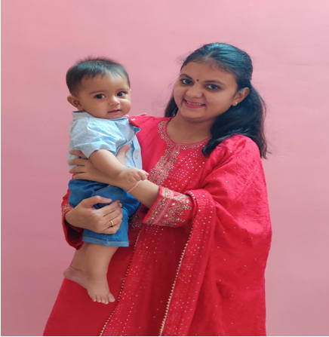
I would like to express my gratitude to Rajshribehan and Tapovan for their invaluable contributions in making my pregnancy a really unforgettable experience.

Shishuparamrshan: Guidance and education given to a woman after conception for her safety and optimal development. Awareness programs were done. Distribution of nutritious snacks is done.
After the birth of the child, the mother was given education to bring him up well. For this, extensive awareness programs about infant counseling were conducted.
Case Study - 2
Shishuparamarshan is a whole new learning world for both parents and child together. I got to know about it through a family reference. The first meeting with Ms Divya Raval and we were sure to join the classes. We joined the classes when Rudransh was 4 months old. The sessions taken by experts for the specific age group makes it so easy for our child to learn about different senses, feelings, vibes, sound, texture. There is no hurry here. Each child is given their own time to learn. The motivation and solutions to various parenting queries makes a lot difference to our upbringing pattern. Rudransh didn't crawl at home, but seeing kids of his age in class made him learn crawling. My child is growing with habits of praying once he is up from his bed. He touches mother earth to say thank you after I recite shlokas. He says Jay Krishna to each of the family members present. Also he is fond of tablas and the music session in shishuparamarshan fills him joy.
The sessions have also taught us (parents and other members of my family) many different ways of dealing with difficulties faced by child. Also we have become more creative. Before we teach Rudransh anything, we ourselves adapt it first. Also singing and dancing has become a part of our daily schedule with Rudransh.
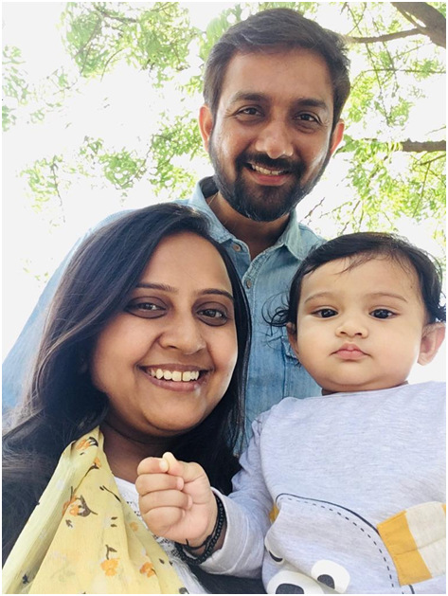
I really appreciate the efforts put in by the whole team for the concept of such kind learning without gadgets and with nature.
Case Study - 3
Introduction: Fieldwork in social work is a critical component of the Master of Social Work (MSW) program, providing students with opportunities to engage directly with communities, apply theoretical knowledge, and develop skills to address social issues. This case study report explores the experiences of MSW students involved in community intervention as part of their fieldwork.
Background: In this case study, we will focus on the experiences of a group of MSW students from a reputable university who were placed in a diverse urban community as part of their fieldwork. The students were tasked with designing and implementing a community intervention project aimed at addressing a specific social issue.
Objectives of Community Intervention: The primary objectives of the community intervention project were as follows:
- Identify a pressing social issue within the community.
- Develop and implement a targeted intervention strategy.
- Collaborate with community members and organizations to maximize impact.
- Evaluate the effectiveness of the intervention and make recommendations for sustainability.
Community Setting: The community in question is a densely populated urban neighborhood characterized by socio-economic disparities, high crime rates, limited access to quality healthcare, and educational challenges. The MSW students were placed in this community to address one of these pressing issues.
Community Intervention Activities and Responsibilities: The MSW students, under the guidance of their fieldwork supervisors, engaged in various activities and responsibilities during the community intervention project:
- Needs Assessment: The students conducted surveys, interviews, and focus groups with community members to identify the most pressing issues.
- Project Design: After analyzing the data, the students collaboratively designed an intervention project focused on improving access to educational resources for at-risk youth in the community.
- Partnerships: They forged partnerships with local schools, youth organizations, and community leaders to gain support and resources for the project.
- Implementation: The students organized tutoring sessions, after-school programs, and workshops aimed at enhancing the academic and life skills of at-risk youth.
- Monitoring and Evaluation: They collected data on participant outcomes and program effectiveness to make ongoing improvements.
Challenges and Learning Opportunities: The MSW students encountered several challenges and learning opportunities throughout the community intervention project:
- Community Resistance: Some community members were initially skeptical of outside interventions, teaching students the importance of building trust and rapport.
- Resource Constraints: Limited resources required the students to be creative in seeking donations, volunteers, and in-kind support.
- Cultural Competence: Engaging with a diverse community necessitated cultural sensitivity and adapting interventions to meet the unique needs of different cultural groups.
- Conflict Resolution: Managing conflicts within the community and among project participants helped students develop conflict resolution skills.
Achievements and Outcomes: By the conclusion of their community intervention project, the MSW students had achieved the following:
- Improved educational outcomes and life skills for at-risk youth in the community.
- Fostered positive relationships between community members and outside agencies.
- Demonstrated the value of social work interventions in addressing pressing community issues.
- Contributed to the development of sustainable community programs beyond the scope of their fieldwork.
Conclusion: The community intervention project undertaken by these MSW students demonstrates the potential for social work to create meaningful change at the community level. The students were able to apply their theoretical knowledge, adapt to challenges, and develop valuable skills in program development, community engagement, and evaluation. Their work exemplifies the importance of fieldwork experiences that immerse students in real-world social work practice.
Recommendations:
- Continue to provide MSW students with opportunities for community-based fieldwork experiences.
- Encourage students to engage in ongoing reflection and supervision to maximize their learning during community interventions.
- Promote the development of culturally competent and community-sensitive interventions.
- Celebrate and share success stories to inspire future MSW students to engage in community interventions.

Parent Orientation: Parent orientation programs were conducted for the holistic development of children between the ages of three to eight years.
Arts Activity: During the year 2017-18, students from Gandhinagar area schools came to the university on the first, third and fifth Saturdays of the month to gain knowledge on various subjects and programs were organized to develop painting, music, drama, dance and creative arts.
Kalamrutam:
Children were sitting at home due to the Covid-19 situation. They used to laugh because of being imprisoned in the house. An online summer camp was organized by the Vidyaniketan department for their entertainment and development at a time when many psychological problems were coming to their attention. From 21st to 25th May, there were programs like song-music, toy making, painting, sports, comedy through BISAG and YOUTUBE with 76600 registrations and 295633 viewers.
Case Study - 4

